**IT24610817**

**Gunasena B.R.S.**

**Probability and Statistics – IT2120**

**Lab Sheet 09**

1. i)

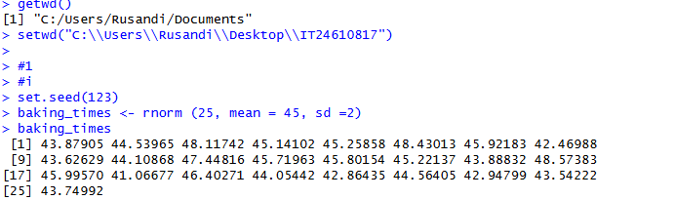

ii)

